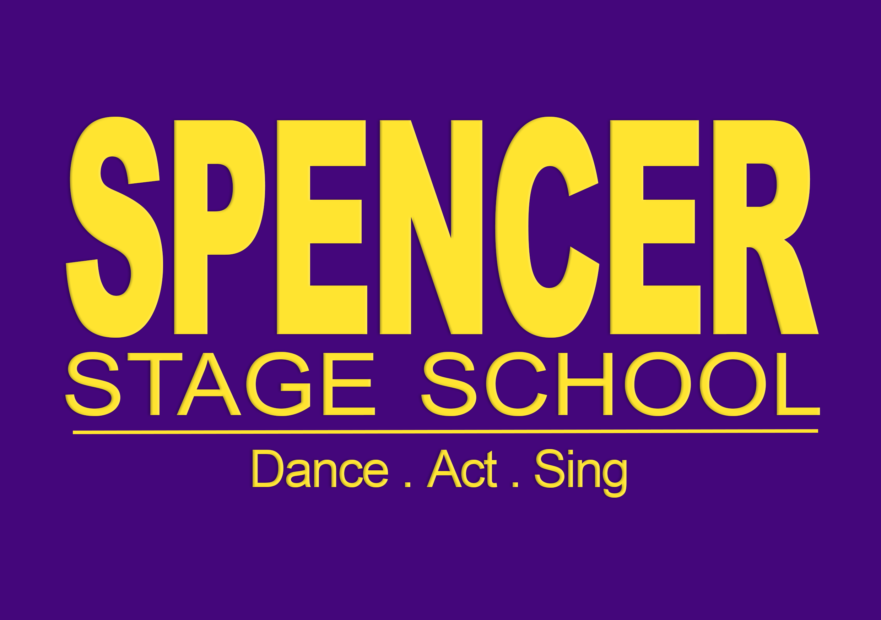
Required uniform for Class, Events & Dance Exams
General Uniform for Arrival at shows and events:
- Spencer T-Shirt
- Black leggings (boys may wear track suit bottoms)
- Black socks
- Black Jazz shoes (Black trainers allowed if outdoor event.)
- Spencer Hoody
- Nude body leotard for changing backstage at shows for girls aged 11 +
- No jewellery allowed.
Street Dance:
Girls:
- Spencer Stage School T-Shirt/leotard/crop top
- Black leggings/Spencer Leggings/Spencer shorts
- Black socks
- Trainers
Boys:
- Spencer Stage School T-Shirt/dance top
- Black tracksuit bottoms/spencer shorts
- Black socks
- Trainers
Musical Theatre/Saturday School/Freestyle:
Girls:
- Spencer Stage School T-Shirt/leotard/crop top
- Black leggings/Spencer Leggings/Spencer shorts
- Black socks
- Jazz shoes
Boys:
- Spencer Stage School T-Shirt
- Black tracksuit bottoms/shorts/leggings
- Black socks
- Jazz shoes
Ballet:
Girls:
Prep & Primary:
- Purple skirted leotard
- Pink ballet socks
- Pink ballet shoes
Grade 1 +:
- Pink Tights
- Pink ballet shoes
- Purple leotard/Spencer leotard
Boys:
- Black leggings
- White tight tank top/leotard (spencer top can be worn for class)
- White socks
- White ballet shoes
Mini dancers/Jazz/Contemporary/Lyrical:
Girls:
Minis/Prep & Primary:
- Purple skirted leotard
- White socks
- Black jazz shoes
Grade 1 +:
- Black socks
- Black jazz shoes
- Black/Spencer leggings or shorts over the leotard
- Purple/Spencer leotard or crop top
Boys:
- Black leggings
- Tight Black tank top or leotard (or unitard) Spencer top can be worn for class
- Black socks
- Black jazz shoes
Foot Thongs may be worn for contemporary and some jazz classes.
Tap:
Girls:
Prep and Primary:
- Purple skirted leotard
- White socks
- Tap shoes
Grade 1 +:
- Black socks
- Black Tap shoes
- Black/Spencer leggings over the leotard
- Purple/Spencer leotard
Boys:
- Black leggings
- Tight Black tank top or leotard (or unitard) Spencer top can be worn for class
- Black socks
- Black tap shoes
Acro:
Girls:
- Purple/Spencer leotard
- Black/Spencer shorts or leggings over leotard
- Bare feet
Boys:
- Black leggings or shorts or unitard
- Spencer Top/Tight Black tank top or leotard (or unitard)
- Bare feet
Drama:
- Spencer Stage School T-Shirt/leotard/crop top
- Black leggings or tracksuit bottoms.
- Black socks
- Black jazz shoes
Hair Guidelines:
- Must all be off the face and tied back.
- Gel. Gel. Gel. Gel is better than hairspray and also better for the environment!
- For exams it must be off the neck for all styles except street or drama.
- Please check our Facebook page for guidance on hair requirements.
Exam Appearance Guidelines:
- No make-up (unless over the age of 13 and want to wear a little mascara).
- Please come without any jewellery at all, this includes: necklaces, earrings, watches, friendship bracelets, etc. The IDTA are very strict about this.
- No tattoos on show for exams. Use masking tape to remove children’s tattoos. If you have permanent tattoos please cover with makeup.

Where to purchase
Spencer T-shirts, Hoody’s, Bags can be purchased on the parent portal online store.
General dancewear, including the none branded purple leotards and skirted leotards can be purchased through ‘my dance store’
Our new branded uniform (as modelled at the Annual Show) can be purchased from the online shop in the booking portal.
Note these are external suppliers and lead time for deliveries can be long.

